Annuity Service Page

People who purchased an annuity or are receiving payments from a structured settlement may need help with some of the following items:

1. Setting up direct deposit for a bank account
2. Getting a copy of a lost or misplaced annuity policy
3. Changing an address
4. Changing the bank account where they are receiving payments
5. Reporting the death of someone receiving or set to receive payments from an annuity
6. Changing a beneficiary
7. Asking questions as to when payments will start or how they are set up
8. Just have annuity questions in general

The following life insurance companies have well-trained customer service specialists who are there to help annuity holders. We have put together a list of companies that we work with, or have worked with in the past, and how to call their customer service associates.

Some companies have websites that allow you contact them via email and fax. When possible, we have included those pages along with the phone numbers.

AEGON
http://www.aegonstructuredsettlements.com/
800-866-0002

Allstate Life Insurance Company
800-840-3870/877-690-4092(FAX)
American General Life Insurance Company
800-288-4088 ext 8006

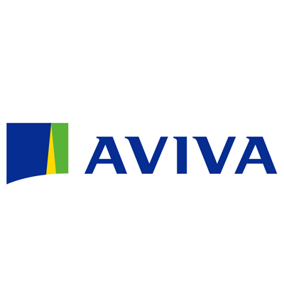
Aviva Life and Annuity Company http://atheneannuity.com/customerservice/service-forms/
888-285-4332
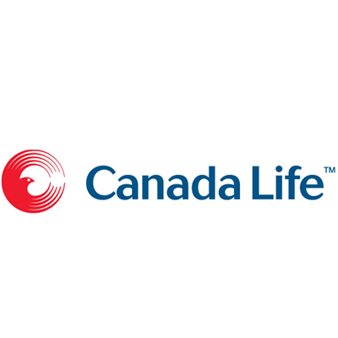
Canada Life
800-879-8271

Commonwealth Life
(see AEGON)
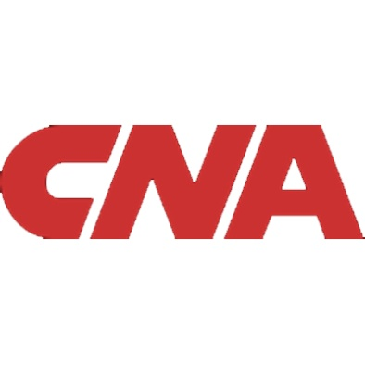
CNA/Continental Life
877-633-5217

First Colony Life Insurance Company
(see Genworth)
GE Capital Assurance Company
800-432-6631
Genworth Life
800-432-6631

Hartford Life Insurance Company
800-678-2282

Jackson National https://www.jackson.com/forms/FormsSearch.jsp?framework-guid=36005e009a8ddc2b479d01a500980077
1 (877) 565-2968
John Hancock Life Insurance Company (U.S.A.)
866-275-5477 option 2
Liberty Life Assurance Company
https://www.liberty-life.com/omapps/ContentServer?c=Page&p=1037792383906&pagename=Life%2FPage%2FLifeFull&cid=1239998133941
800-451-7065 option 2
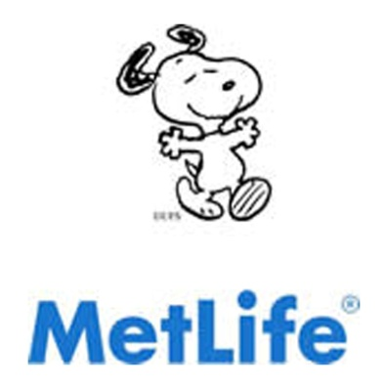
Metropolitan Life Insurance Company/MetLife Insurance Company https://www.metlife.com/institutional-retirement/brokers/torts-settlements/index.html#settlements
800-427-9409
MONY, Mutual of New York and AXA
https://us.axa.com/customer-service/overview.html
(800) 487-6669

New York Life Insurance Company https://www.nylss.com/ss/v/index.jsp?contentId=152703&vgnextoid=3458966ccf317310VgnVCM100000ac841cacRCRD&vgnextchannel=8d0e0a08b7e07310VgnVCM100000ac841cacRCRD
212-576-6243
Pacific Life Insurance Company/Pacific Life and Annuity
(All cases pre 1/1/2012; NY cases after 1/1/2012) http://ip.rsd.pacificlife.com/ssc/home/structured_settlementannuities.html
888-728-5611
Prudential Insurance Company of America http://www.retire.prudential.com/view/page/rs/16977
888-778-8118
SAFECO Life Insurance Company
(see Symetra)
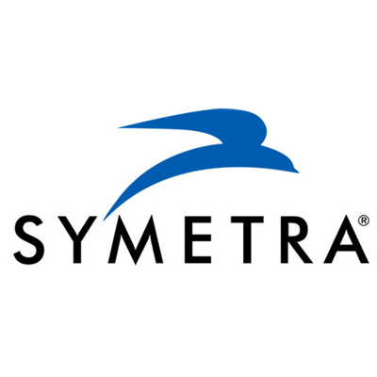
Symetra Life Insurance Company http://www.symetra.com/About/Pages/Contact-Symetra.aspx
800-796-3872
Transamerica Life
(see AEGON)

